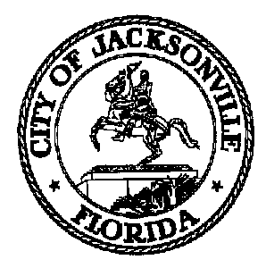
Taxation, Revenue and Utilization of
Expenditures (TRUE) Commission

Daniel Henry, Chair TRUE Commission
c/o Jeff Clements
Suite 425, City Hall
117 W. Duval Street
Jacksonville FL 32202
904-255-5137

TO: TRUE Commissioners

FR: Daniel Henry – Chair

RE: September 16, 2021 TRUE Commission Audit Committee Meeting Cancellation Notice

The TRUE Commission Audit Committee meeting scheduled for Thursday, September 16, 2021 has been CANCELLED and will be rescheduled by separate notice.

For further information contact Jeff Clements at jeffc@coj.net or 904-255-5137.

Jeff Clements, Council Research Division Posted 9.16.21 2:45 p.m.

